Directions to Download TestNav software
ONLY STUDENTS IN GRADES 2-5 NEED TO DOWNLOAD TESTNAV TO COMPLETE AIMSweb assessments.

- Go to download.testnav.com
- Under Laptops and Desktops click “.exe.installer”
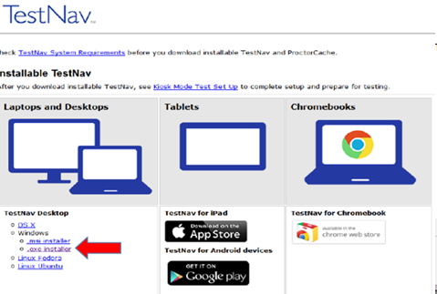
- Wait a few minutes for the installation file to appear. If it doesn’t automatically appear, click the ‘progress of downloads’ button in the top-right corner of the web page. Then click the testnav file.
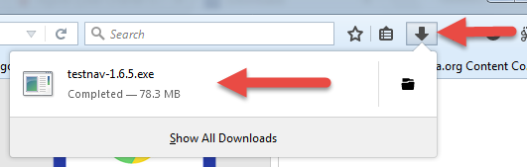
- A pop-up will appear. Click “Save File”.
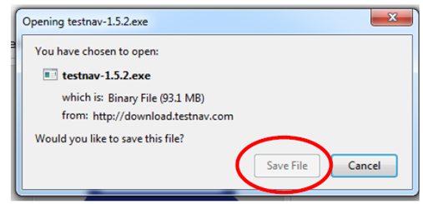
- Click “Run”.
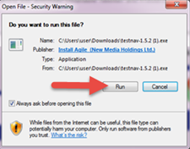
- Click “Yes” to continue.
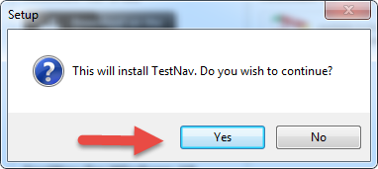
- Click “Yes” to allow the program to make changes to the computer.
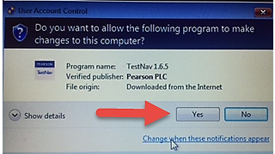
- Follow the prompts as they appear in each window and click “Next”.
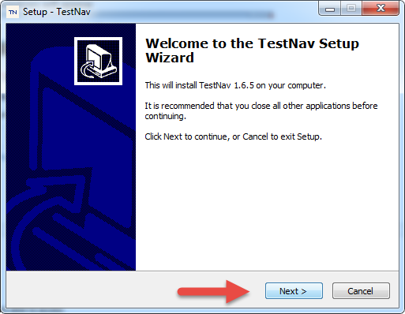
- Click “Install” when the Ready to Install window appears.
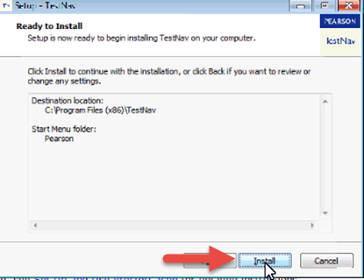
- Click “Finish” to complete the installation and launch the TestNav program
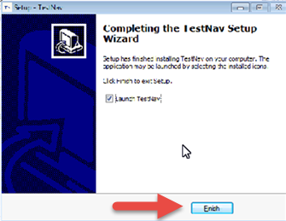
Do not log into TestNav until the scheduled time with your teacher(s). When it is time to complete AIMSweb assessments, click the TestNav shortcut on your Desktop.
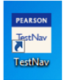
Click “aimsweb Plus” and enter the login provided to you in your Online School email account.
